# Solution- Oriented Requirement

At the end of this topic, students should be able:

1. describe the 3 modeling perspective for solution-oriented requirements
2. Use ER modelling to model data perspective
3. Use UML state machine diagram to model behavioral perspective
4. Use event-based partitioning Data FLow Diagram (DFD) to model functional perspective.

Let us model REQUIREMENTS using graphical models

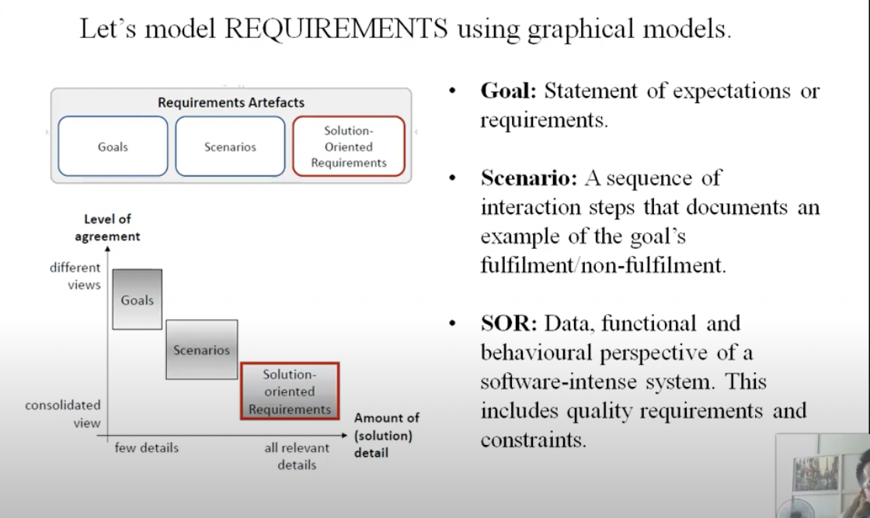

* SOR
* Is based on SNL requirements
* Defines data, functional and behavioral perspectives of a software-intensive system including quality requirements and constraints
* Is complete (detailed), agreed(no conflict, provides intended solution) and documented.
* Is modeled using ERD, DFD, and State Machine Diagram/State Chart
* 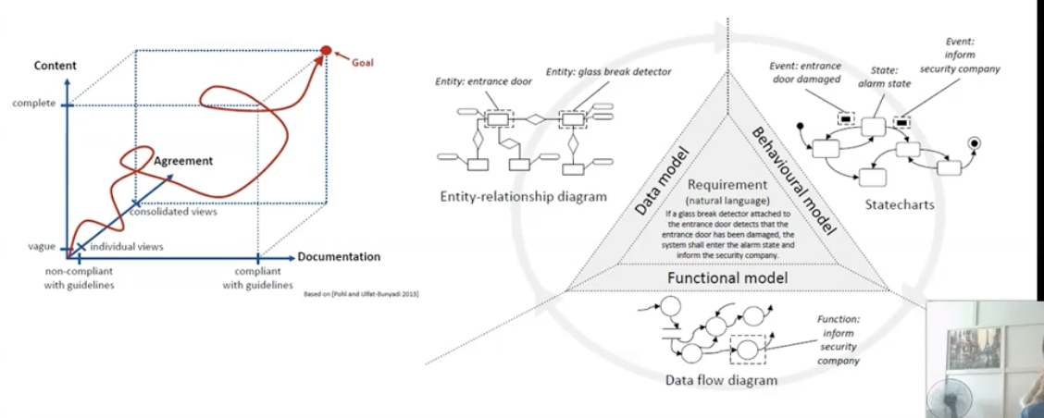

Perspective 1: Data modelling

